**Project Name :**  PCHubSG

**Module Group Number :** 6

**Supervisor :** Dr Kenny Lu

**Group Members :**

Chow Jia Jun (170194A) - Group Leader

Lim Zheng Ting (172026H) - Group member 1

Rebancos Argel James Angeles (170560U) - Group member 2

Liew Jun Wei (171795T) - Group member 3

Tuak Zhong Wei (171609E) - Group member 4

**Latest Report Amendment Date :** 11th August 2018

**Report Version Number :** 3

**Contents Page**

Project Overview and Analysis -------------------------------- 2 - 15

System and User Interface Design -------------------------- 16 – 35

Reflection on Learning Experience ------------------------- 36 – 38

**Project Overview and Analysis**

Our project theme is a second hand market website which specializes in selling / buying used PC components. Our website has the following functions

* Placing bids on hardware
* Chat Functions
* Provides a quick guided way to build a pc
* Have a review system where users can check the trustworthiness of an online seller prior to purchase
* Compare prices and info with listed products
* Setting and edit budget
* Email receipt to users to keep track of their spending

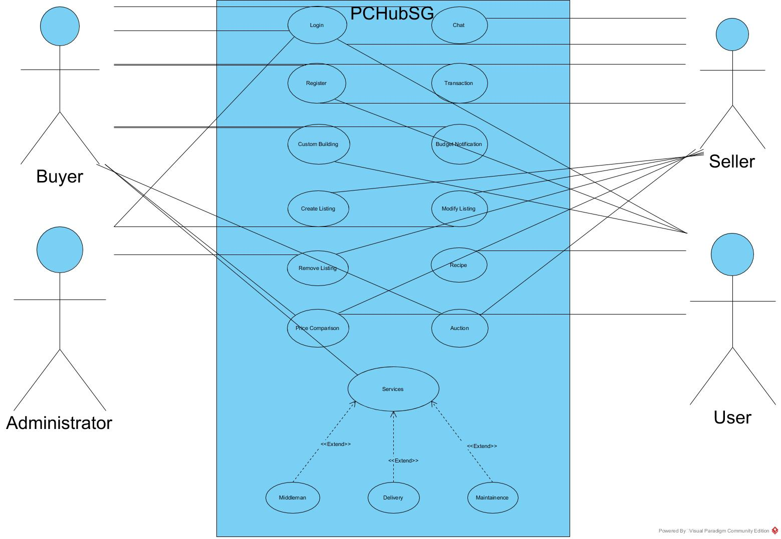

**Checkout Function (Jia Jun)**

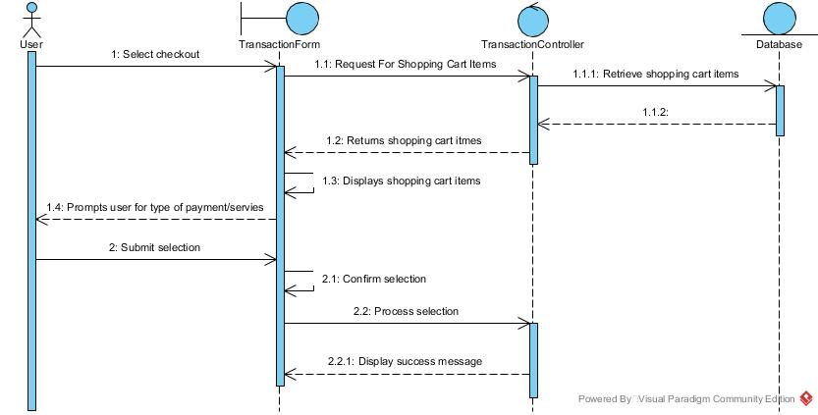

The user will be able to checkout after selecting the items from the listings and the total price of all the product will be displayed at the bottom of the checkout page and the user can select if they want to pay by credit card or paypal

**Shopping cart (Jia Jun)**

The user can add items into the shopping cart and checkout once he or she is done shopping, the user can also remove items from the cart

**Create/Modify/Delete Listings (Jia Jun)**

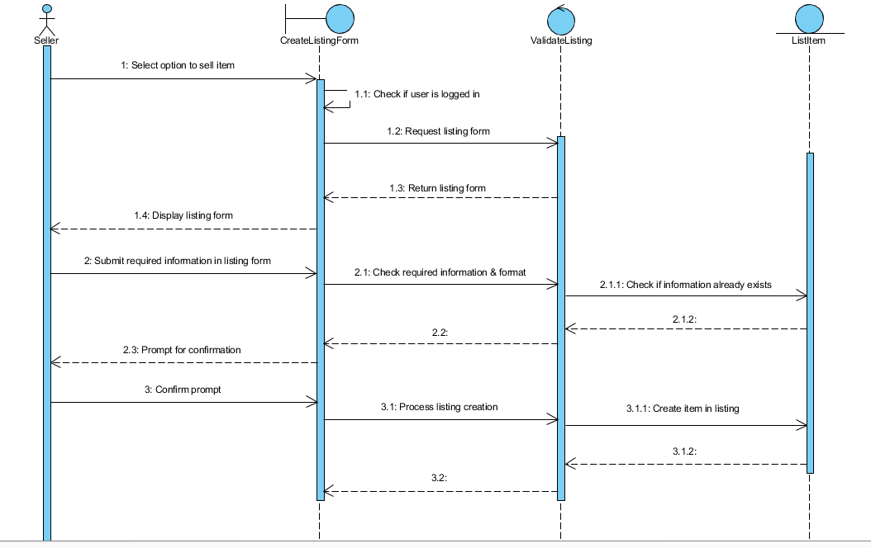

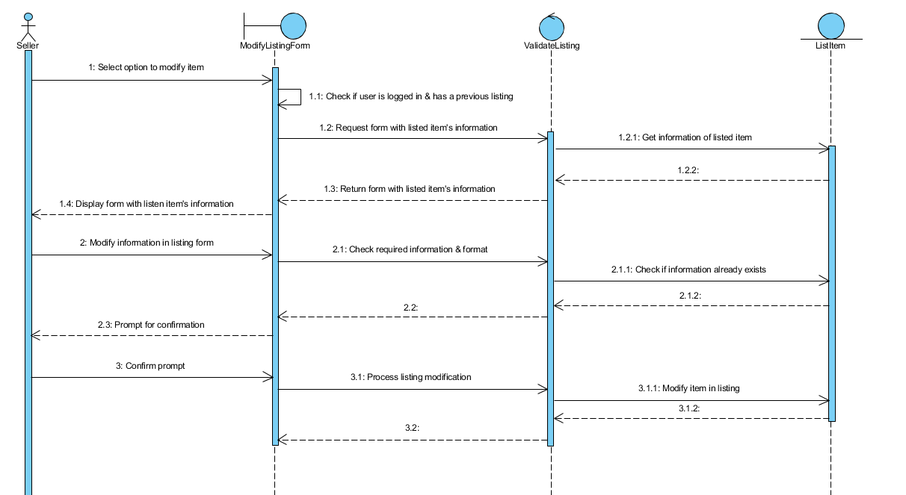

The user can create listings to sell their item and they can modify their listings or even delete them afterwards.

Use Case Title: Create listing  
Pre-condition: The seller has to login to the system successfully  
Post-condition: The system creates the new item successfully  
Basic flow:  
1) The seller selects the option to sell item  
2) The system renders a form containing needed information to create an item for sales  
3) The seller fills in the required information of the new item  
4) The system prompts the seller for confirmation  
5) The seller confirms the information for the new item  
6) The system creates the new item and adds it in the listings  
Alternate flow:  
3a) If the seller has not filled in all the mandatory information, the system does not proceed and alerts the seller of the missing information  
3b) If the information entered by the seller is invalid (wrong format), the system does not proceed and alerts the seller of the invalid information  
5a) If the seller cancels the confirmation prompt, the system returns back to the form with the information still filled in.

Use Case Title: Modify listing  
Pre-condition: The seller has to login to the system successfully and seller must have previously created a listing  
Post-condition: The system will modify the item successfully  
Basic flow:  
1) The seller selects the option to modify on an existing item  
2) The system renders a form with the previously filled up information of the selected item  
3) The seller modifies the information of the item  
4) The system prompts the seller for confirmation to update information of selected item  
5) The seller confirms the modified information  
6) The system updates the information of the selected item and updates it in the listing.  
Alternate flow:  
3a) If the seller has not filled in all the mandatory information, the system does not proceed and alerts the seller of the missing information  
3b) If the information entered by the seller is invalid (wrong format), the system does not proceed and alerts the seller of the invalid information  
5a) If the seller cancels the confirmation prompt, the system returns back to the form with the information still filled in

**Set Budget (Zhong Wei)**

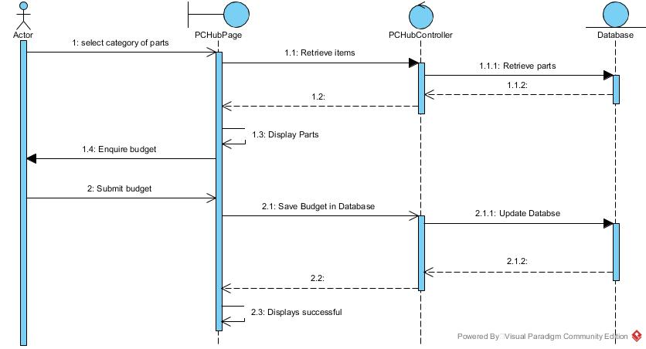

The user will set his/her budget and it will display at the final checkout page what his budget is and it will restrict the user from overspending

Basic flow-set budget

1. Logged in user goes to the set budget page.
2. User enters budget.
3. The system logs the budget amount into database.
4. When user checks out, the system checks for excess in spending.
5. If spending is not in excess, the system passes a successful transaction.

Alternate flow

5a. if spending is in excess, the system blocks the transaction from going any further.

Basic flow-edit budget

1. Logged in user enters the edit budget page.
2. System gets budget from the database that has the same id as the user.
3. System displays the budget.
4. User clicks on edit.
5. The site redirects the user to a page to update the budget.
6. User clicks edit.
7. The system updates the new amount into database.

Alternate flow

4a. the user clicks on delete.

b. the system destroys the budget.

**PC Building (Jia Jun)**

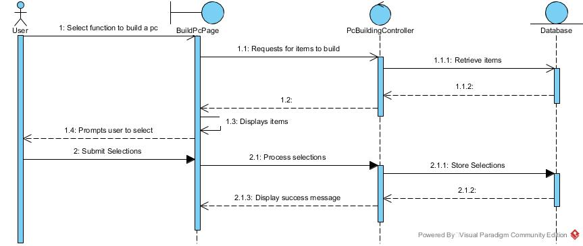

The user can click on the pc building button and they will be redirected to the pc building page where the user only need to select one item from each of the categories and press checkout. The user can also sort according to the price range that they desire.

**Use Case Name :** Build your own/Custom building

**Pre-condition :** The user must be logged in

**Post Condition :** The user will be redirected to the checkout page with all his/her selection

**Basic Flow:**

**1.** The user selects the custom building function

**2.** The system retrieves the parts and displays to the user

**3.** The user selects the parts that he/she wants

**4.** The system saves the user’s selection into the shopping cart

**5.** The system will display success message

**Alternate Flow:**

2a) If the parts have run out of stock, the system will display that the item is out of stock.

**Auction (Argel)**

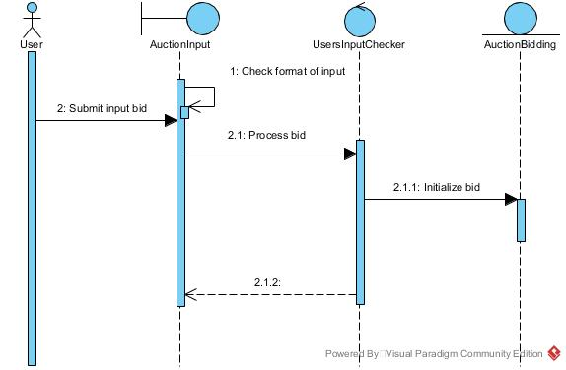

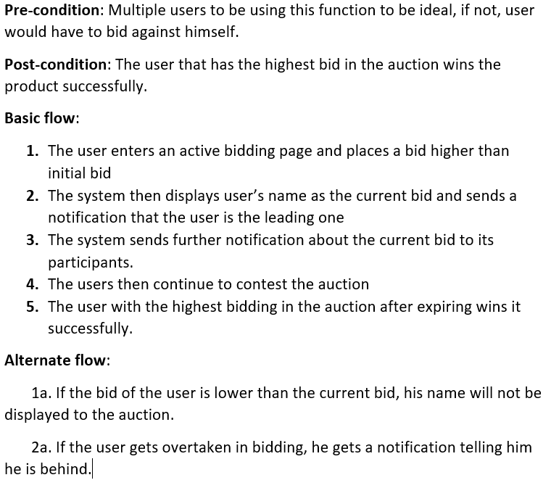

**Chat (Zheng Ting)**

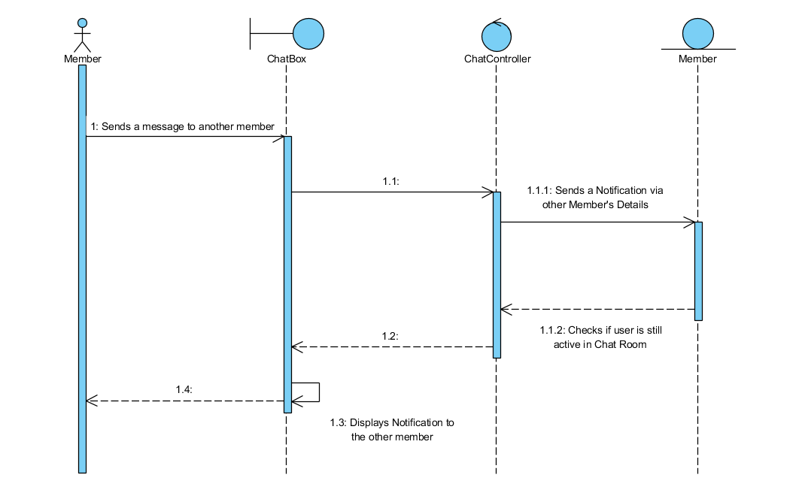

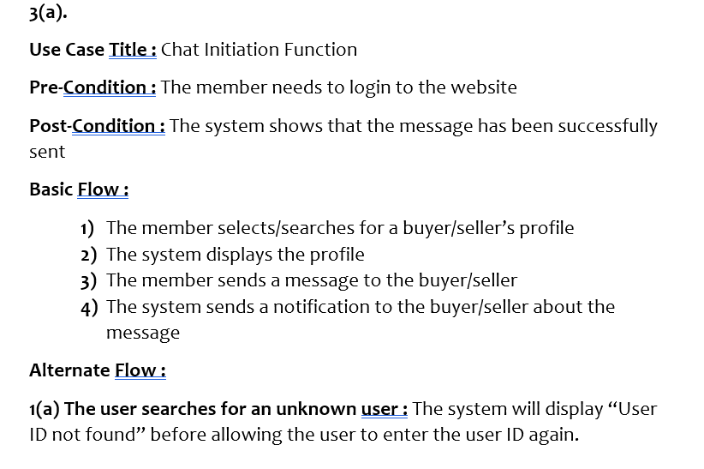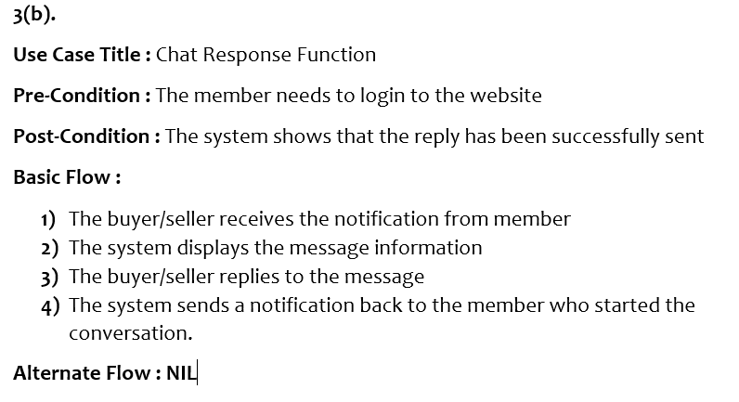

**Notifications (Zheng Ting)**

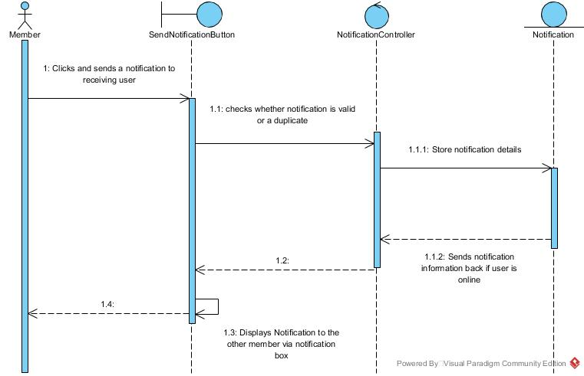

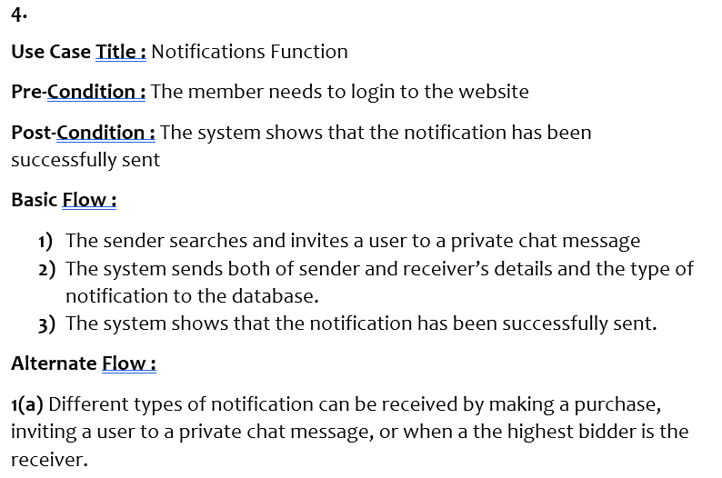

**Login (Zheng Ting)**

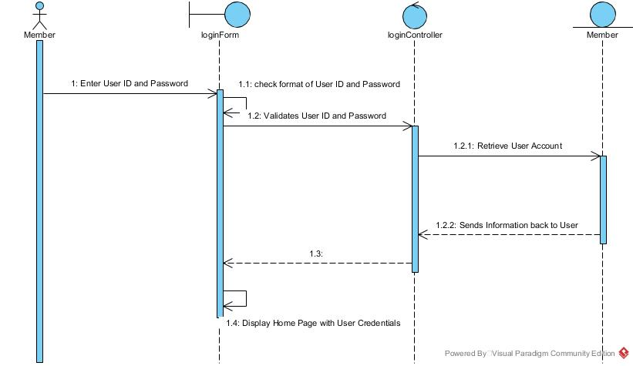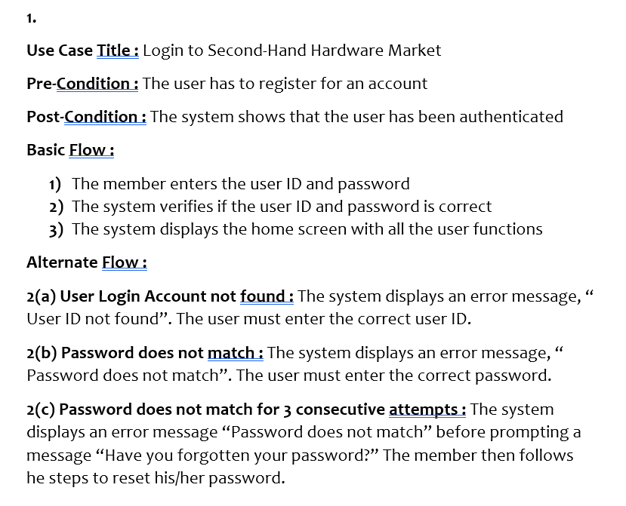

**Register (Zheng Ting)**

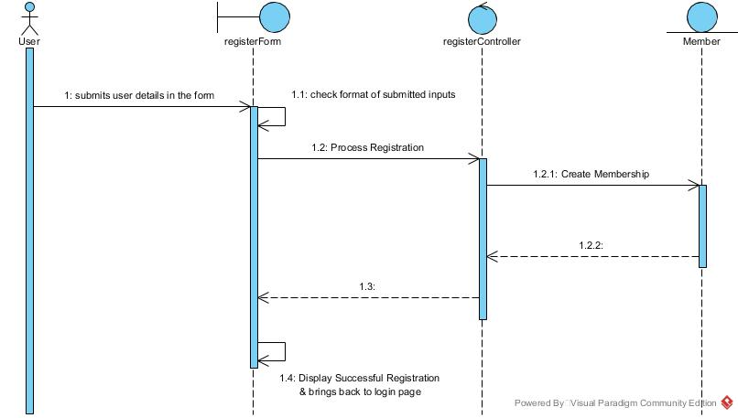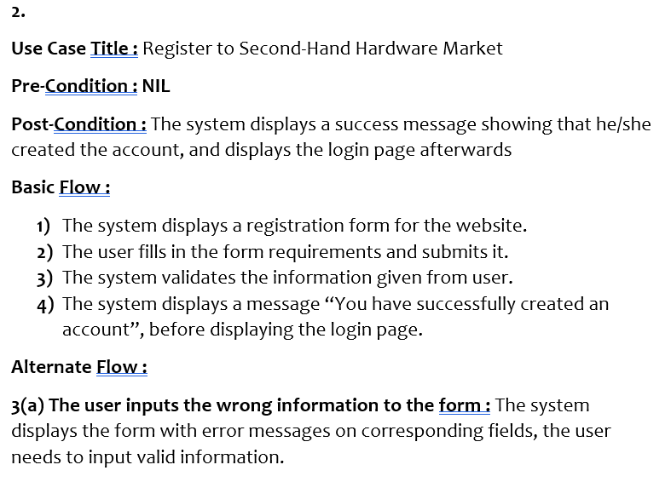

**Compare Items (Jun Wei)**



Use case title: Price comparison  
Pre-condition: The user have to compare two products of the same category.  
Post-condition: The system displays the detail of the comparison to the user successfully.  
Basic flow:  
1. The user reviews the record of trending and popular price comparisons  
2. The user then selects two products of the same category  
3. The system checks that these two products are valid to compare  
4. The system then displays the details of the difference of the two products to the user successfully  
Alternate flow:  
 1a. If the user does not see the two products he wishes to, this executes number (2).  
 2a. One or both of the products is not comparable, the system displays an error to the user.

**System and User Interface Design**

**PC Building Function**

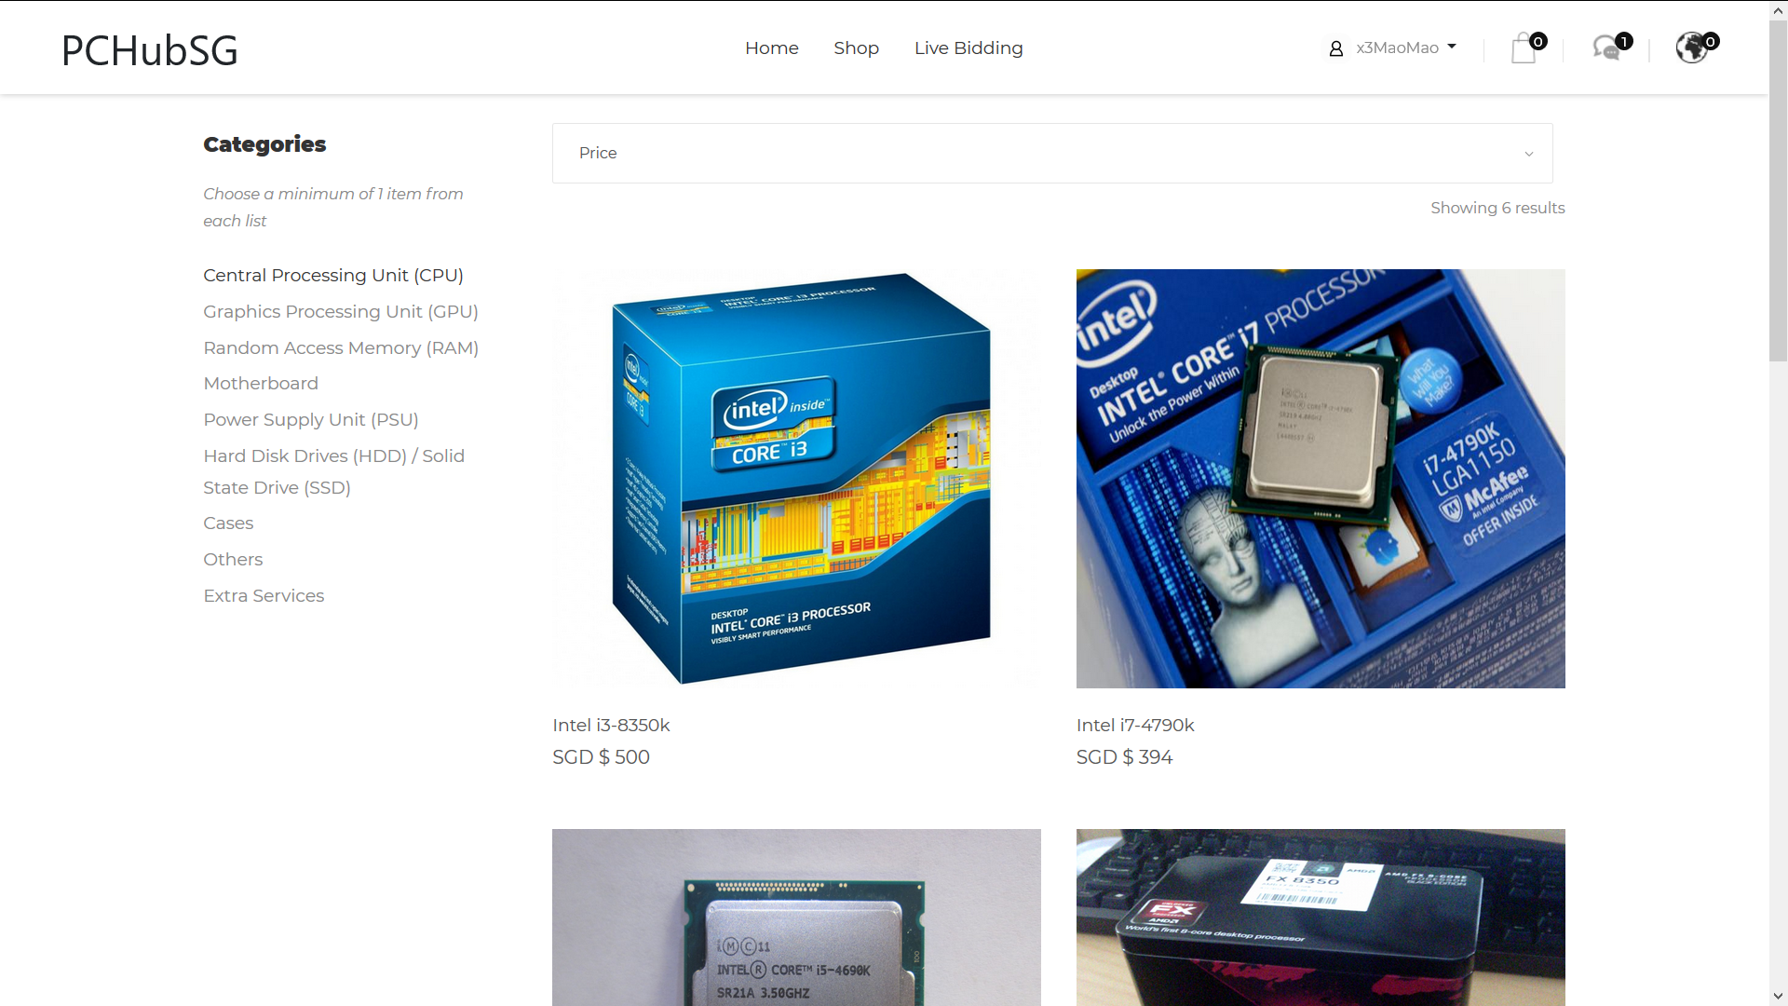

Users can just select which parts they want in each category and add them to cart and they can sort the products according to their price range.

**Use Case Name :** Transaction

**Pre-condition :** The user must have logged in and have something in the shopping cart.

**Post condition :** The transaction for the item will have been completed

**Basic Flow :**

**1.** The user proceeds on to the checkout page.

**2.** The system will display all of the user’s selection

**3.** The user selects the type of payment he/she wants to pay by and optional extra services

**4.** The system will display the user’s payment method and the extra services he/she opted for

**5.** The user chooses to proceed or to edit his/her previous selection

**6.** The system displays the transaction is successful

**Alternate Flow:**

6a) If the user credit card or debit card transaction is rejected, the system displays an error message.

**Checkout Function (Jia Jun)**

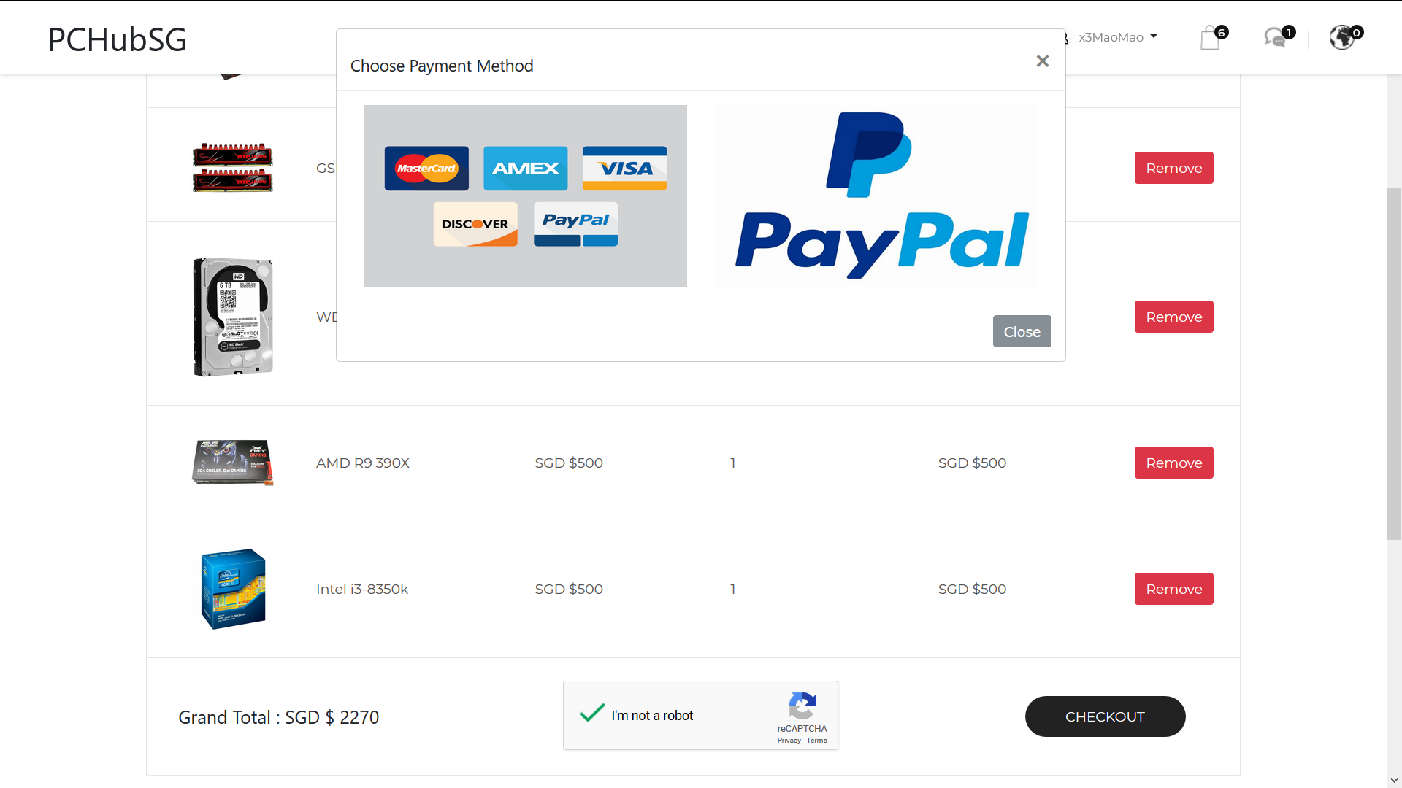

After the user selects the checkout button, he/she will be directed to the checkout page where it will display all the items that he/she had added to the shopping cart and they can choose which payment method he/she prefer to use to pay.

**Set Budget (Zhong Wei)**

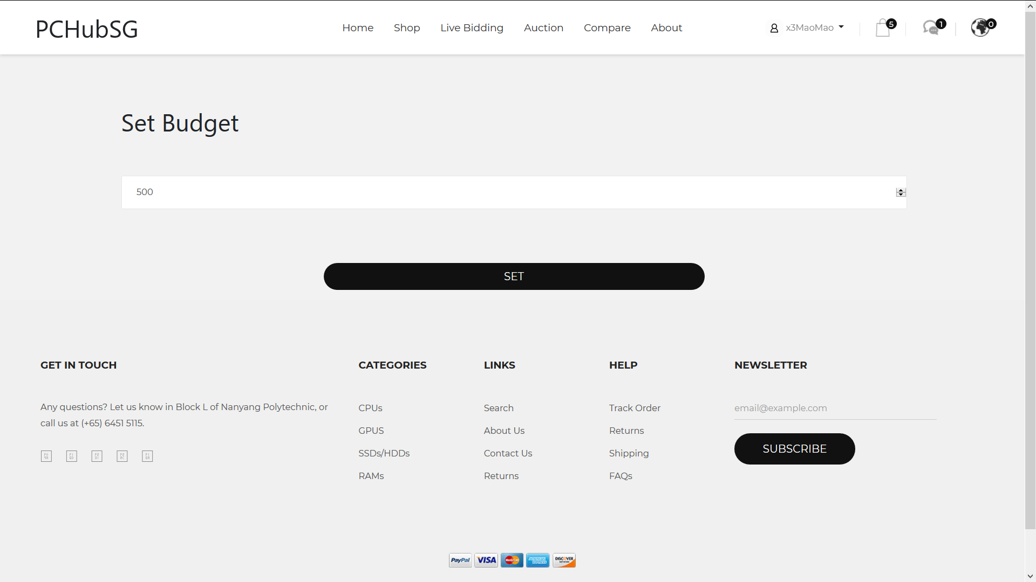

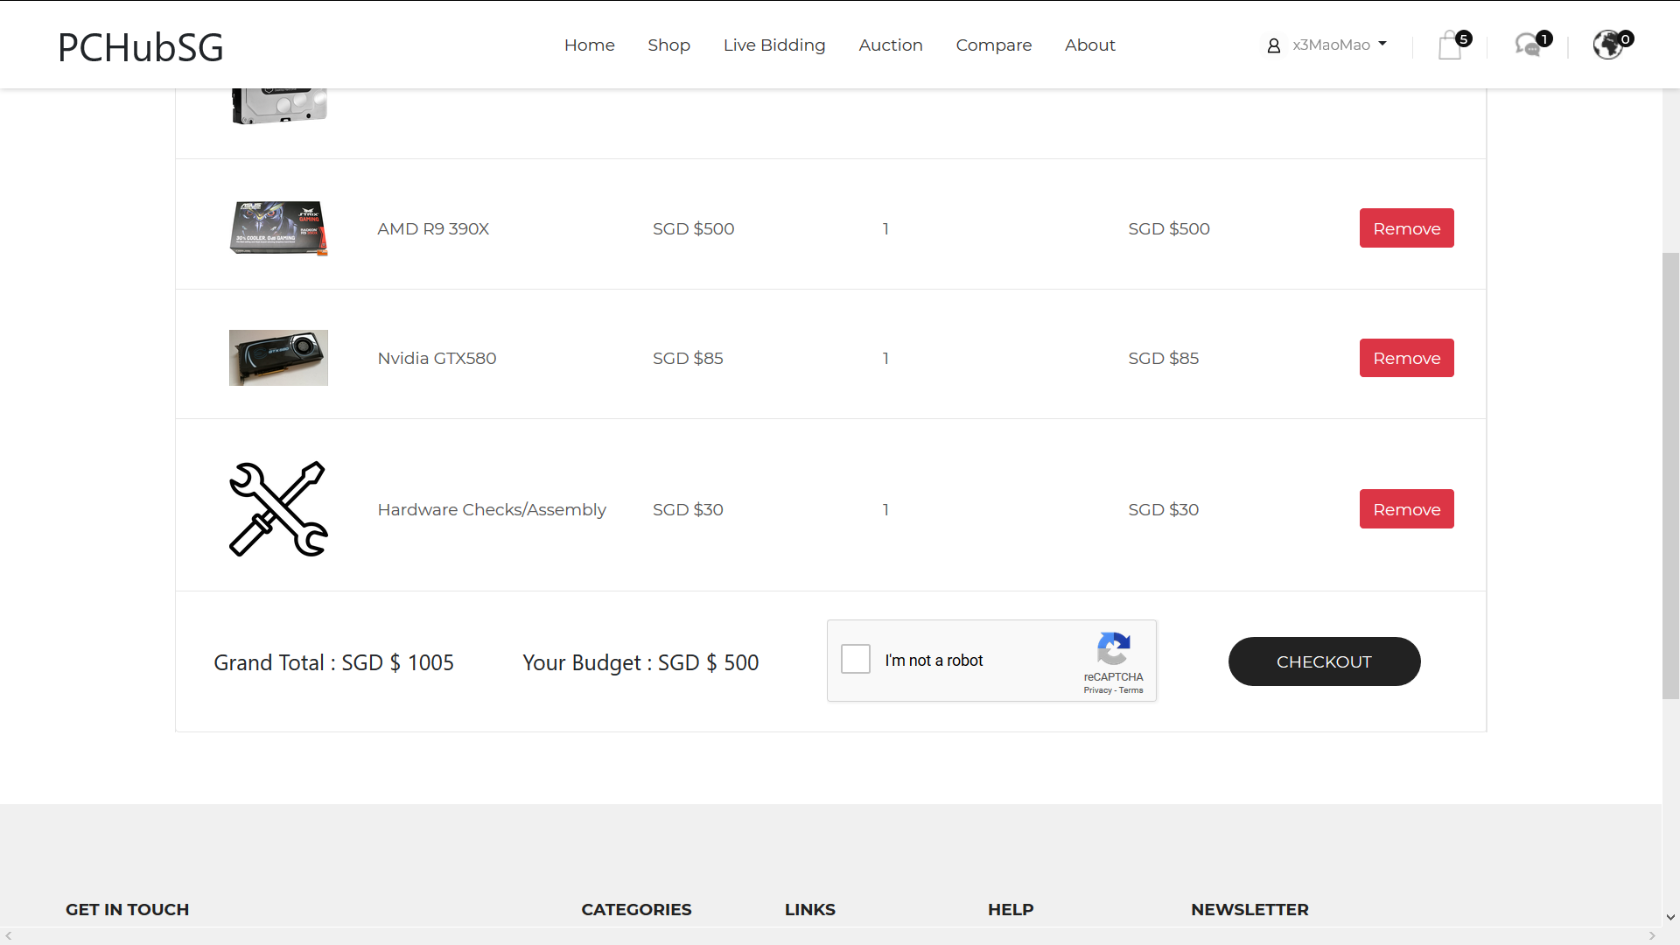

The user can set his or her budget and the budget will appear on the checkout screen and will restrict the user if the total amount is higher than the budget set.

**Shopping Cart (Jia Jun)**

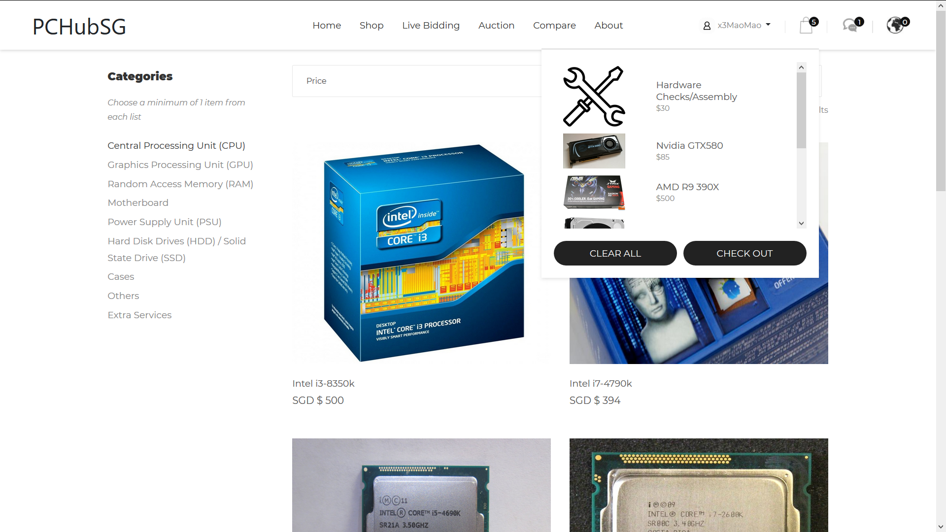

The user will be able to add items into the shopping cart which he/she will be able to checkout once he/she has finished his shopping

**Create/Modify/Delete Listing (Jia Jun)**

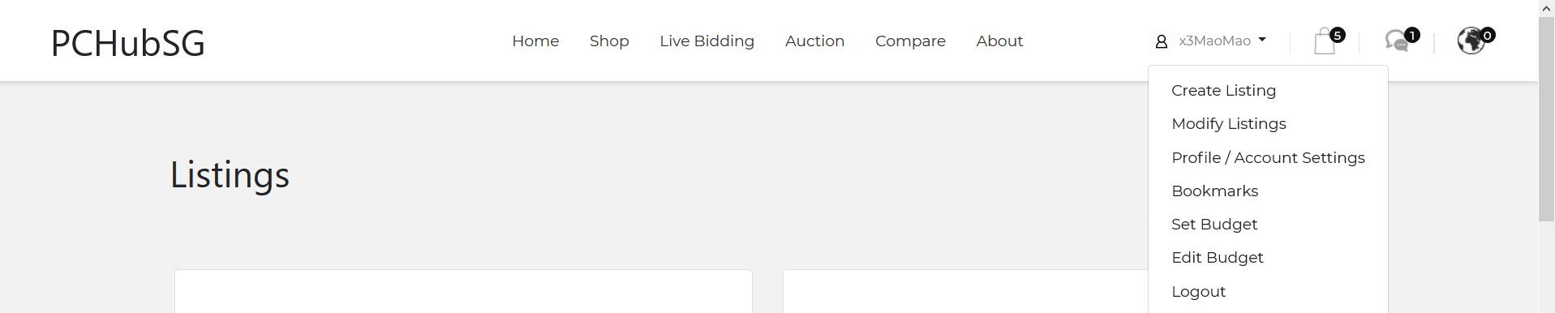

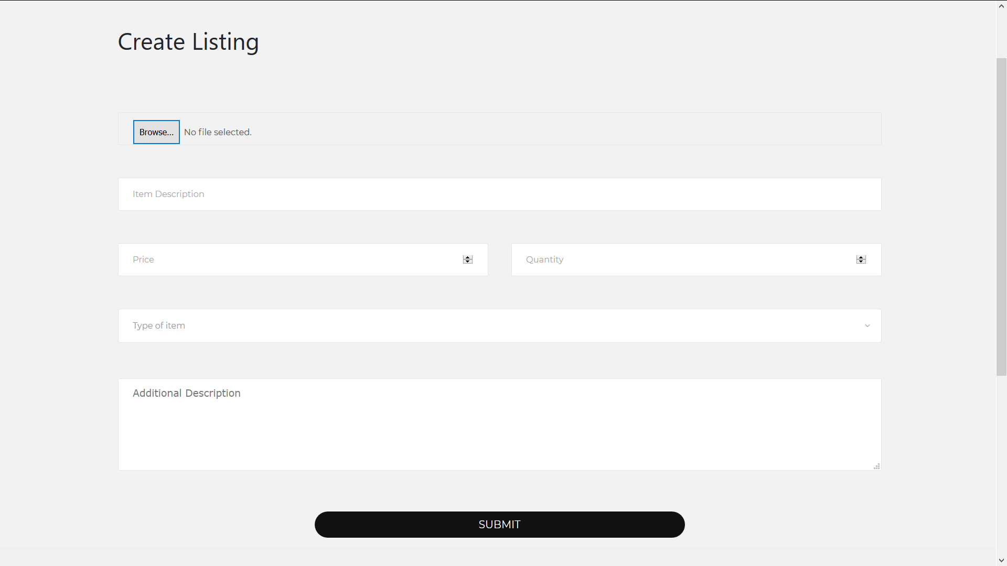

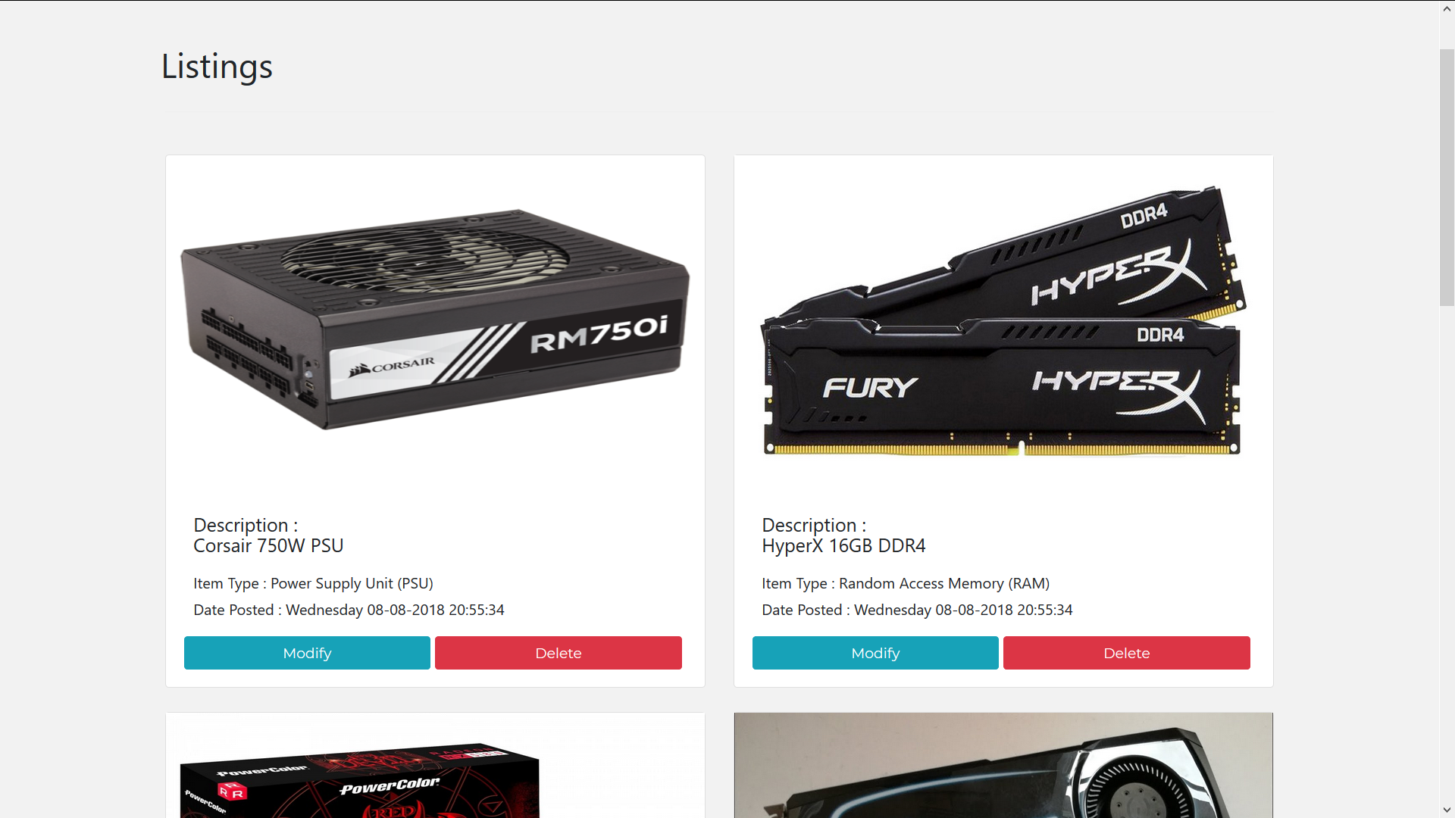

The user can access the create listing and modify listing function through the dropdown box, he/she can create a listing and he/she can also modify/delete it after they have created a listing.

**Profile / Account Settings (Zheng Ting)**

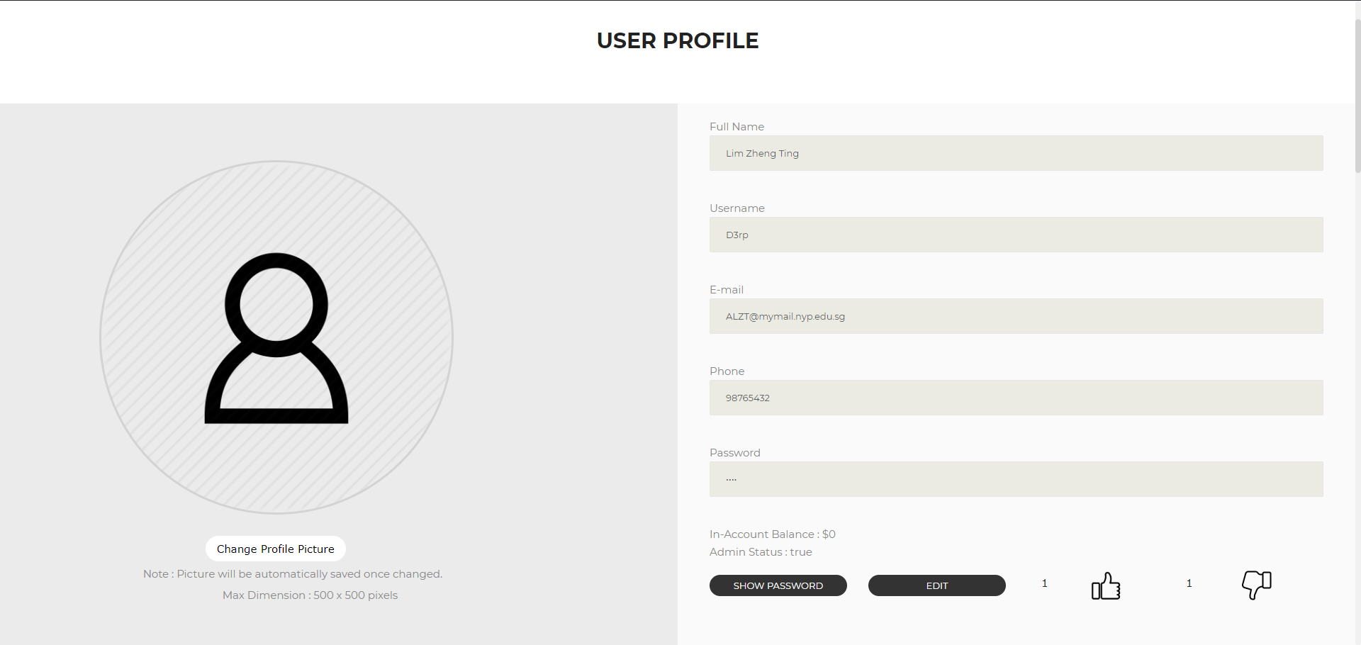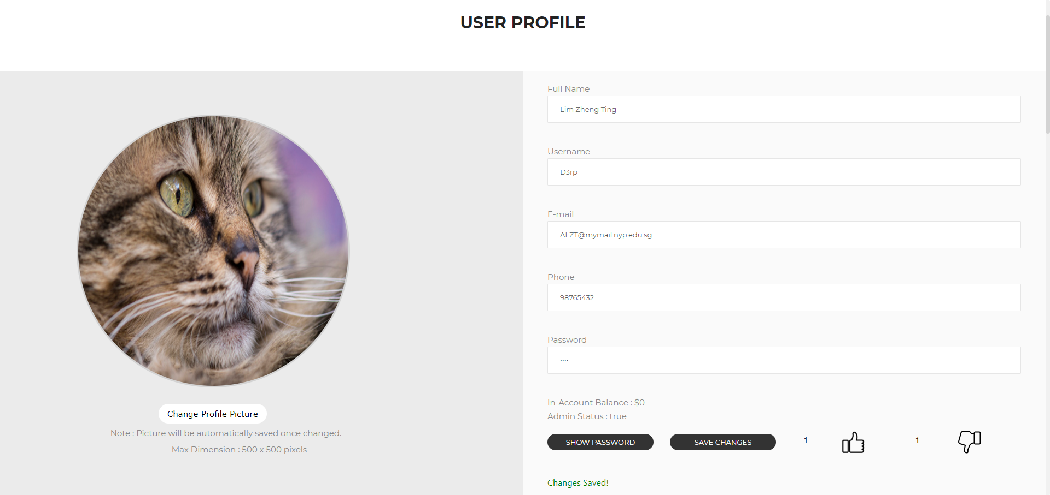

The user can either visit their own profile page, which they can change profile picture / account details on, or view other user’s profile allowed information.

**User Reviews (Zheng Ting)**

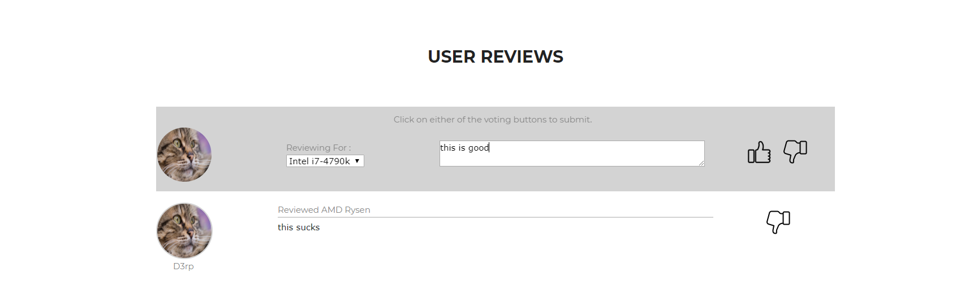

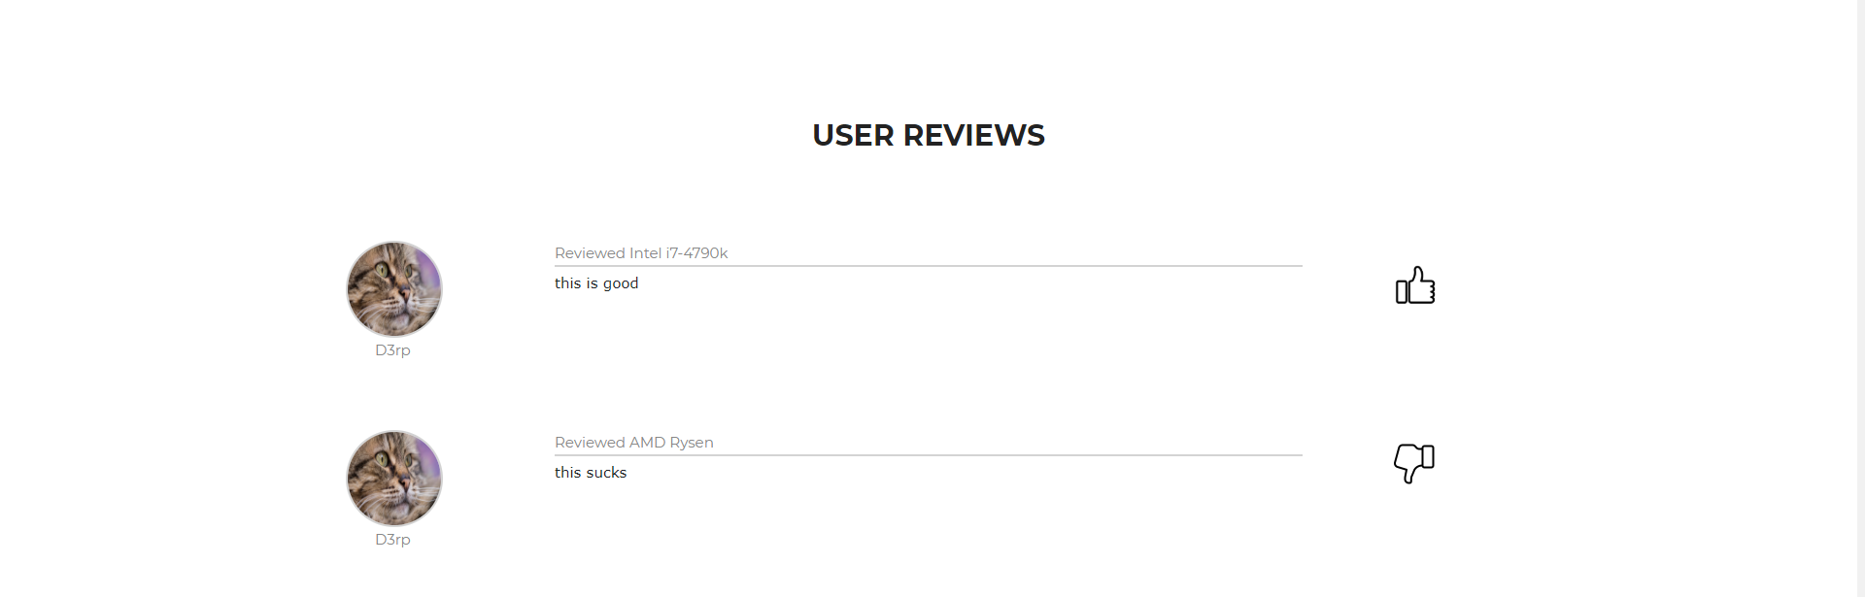

After a user makes a transaction, he can then give reviews to that particular seller and this will display on his / her profile page. It will also sum up the total number of likes / dislikes from reviews and display it at the top of the profile page. This review system can be viewed from any user’s profile page as long as someone has made a review to said user.

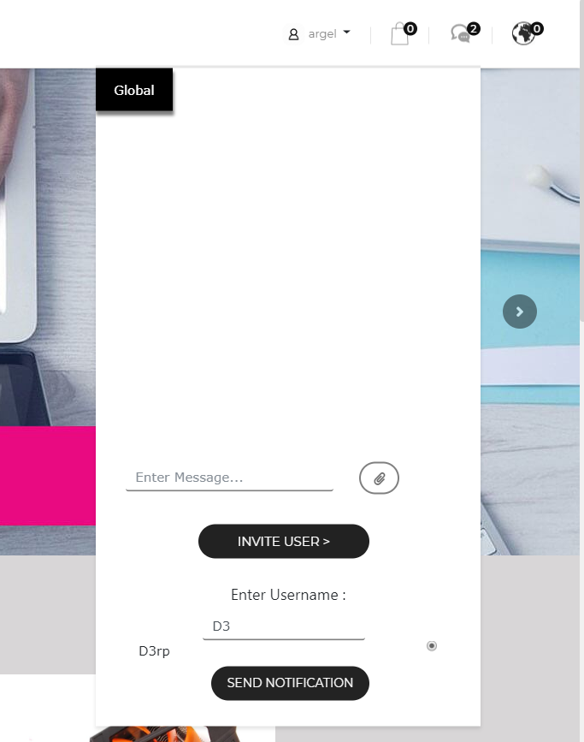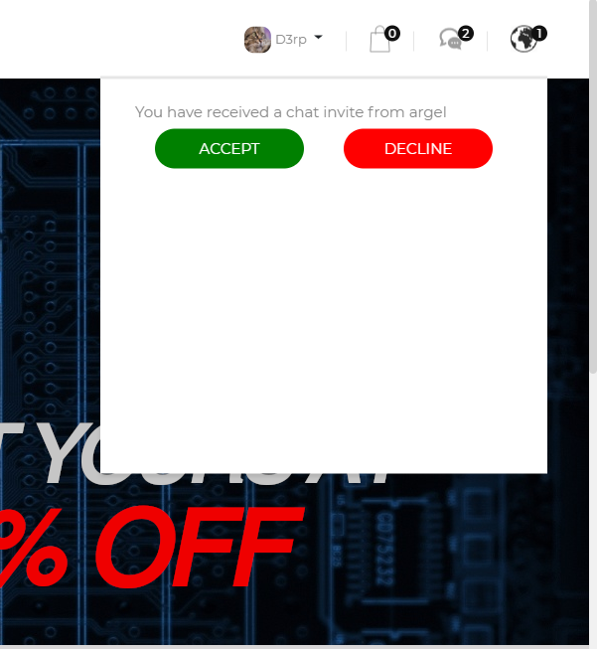**Private Chat Messaging (Zheng Ting)**

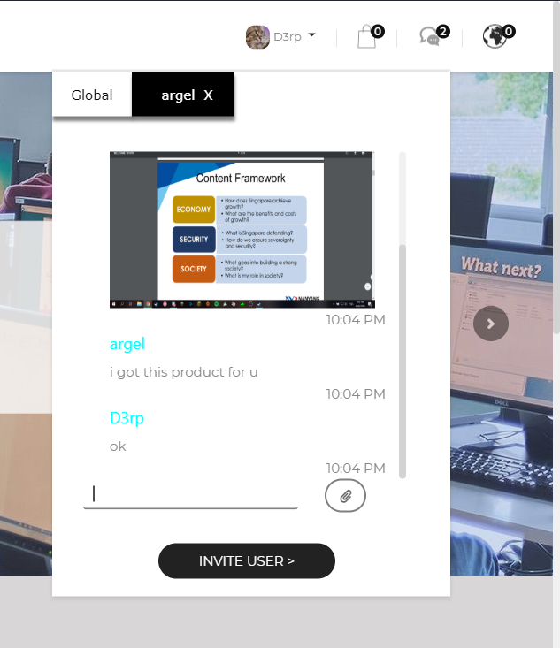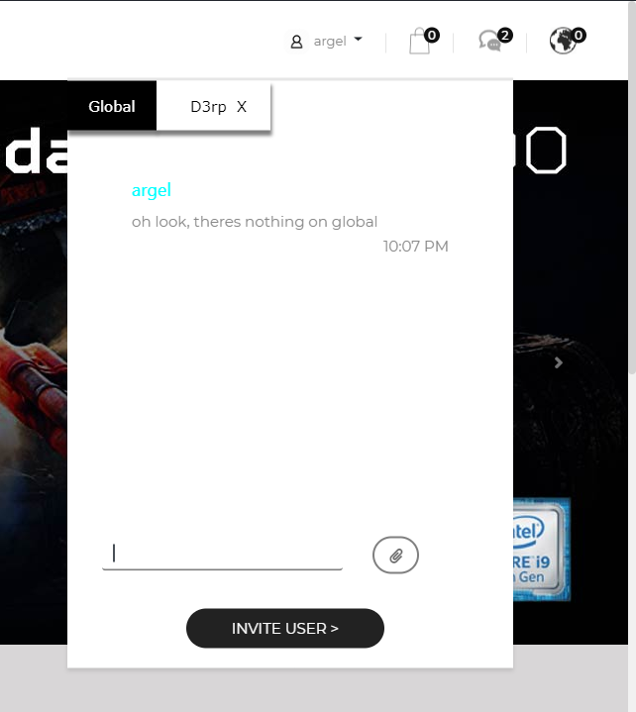

Besides being able to message globally, users can invite each other to a private message by sending it via chatbox or at the front of their profile page. Invited users then receive a notification to accept or decline said invite. Once accepted, they can then chat each other and send images of items to verify them.

**Compare Items: (Jun Wei)**

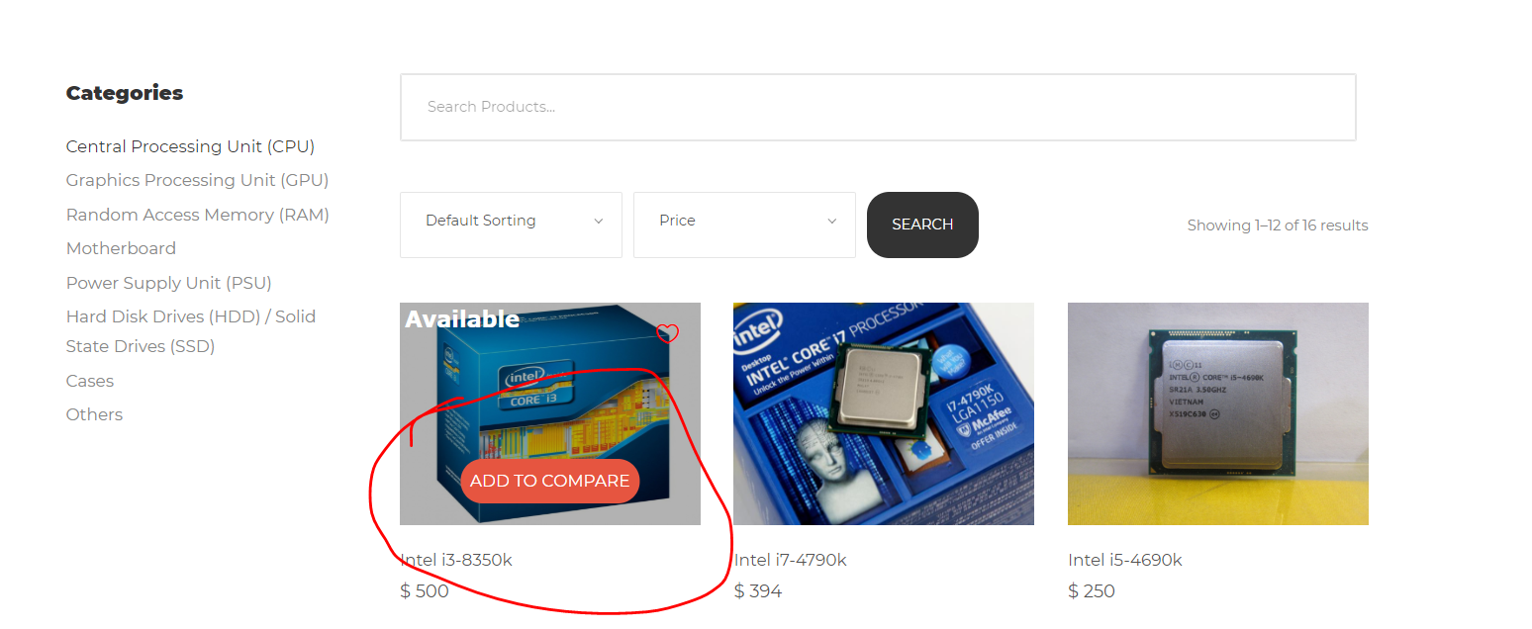

The user can add an item to the the compare list by hovering over the item picture and clicking on the “Add to compare” button.

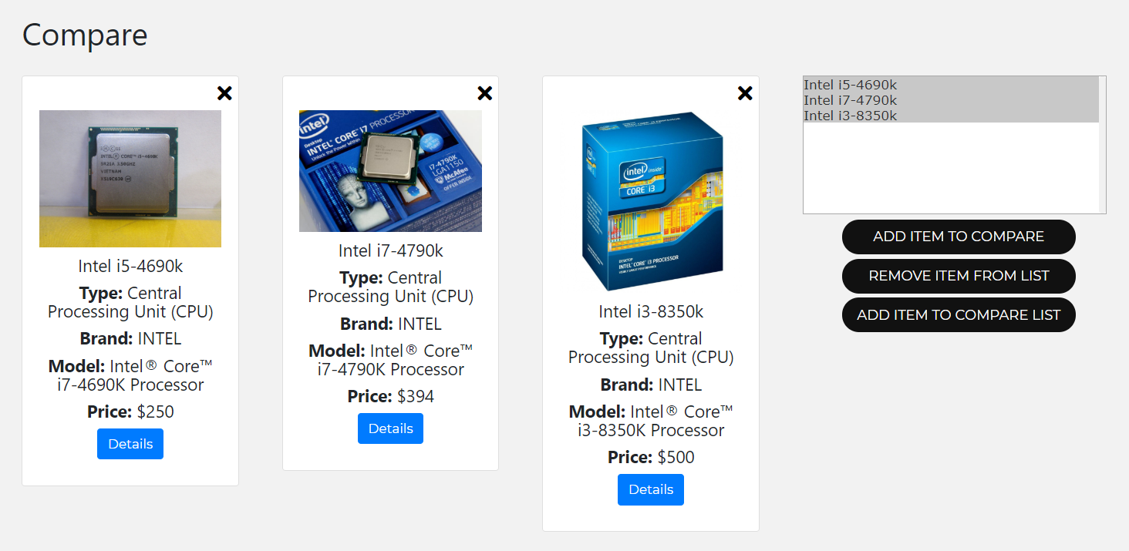

The selected item(s) will then show up here.

The user can compare the items by selecting items from the list on the right and then pressing the button “Add Item To Compare”. The user can remove items from the compare boxes by clicking the cross on the top right hand side of the item. The user can also remove and item from the list by selecting it and pressing the “Remove Item From List” button.

**Bookmarks: (Jun Wei)**

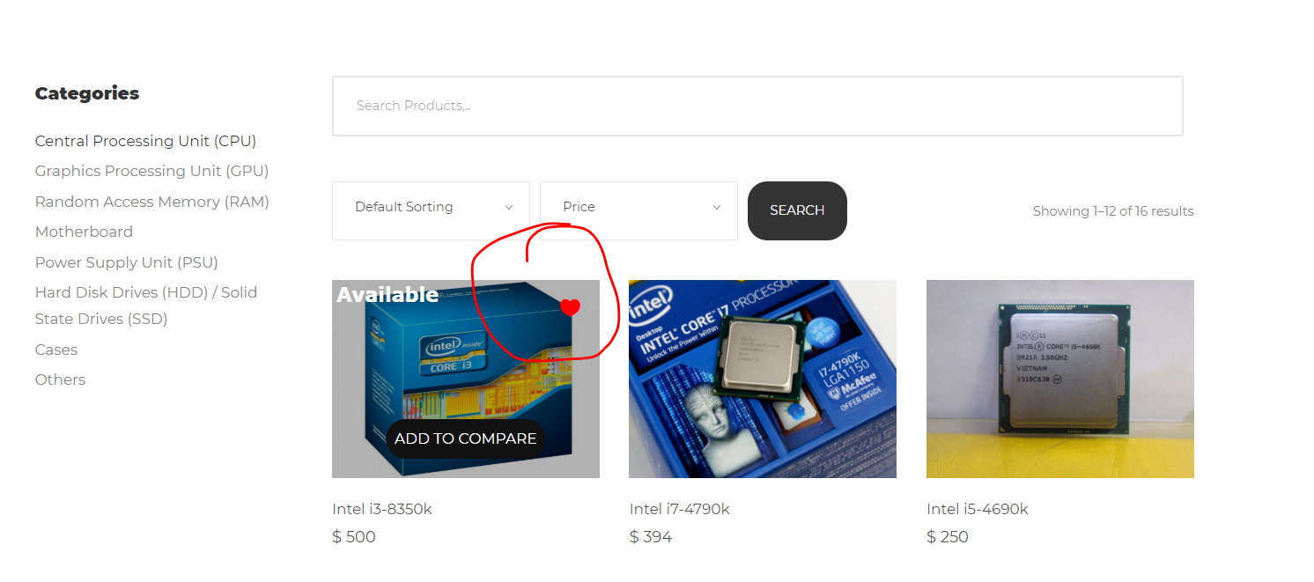

The user can add a bookmark for the item by clicking on the heart at the top right side of the picture when hovering over the selected item.

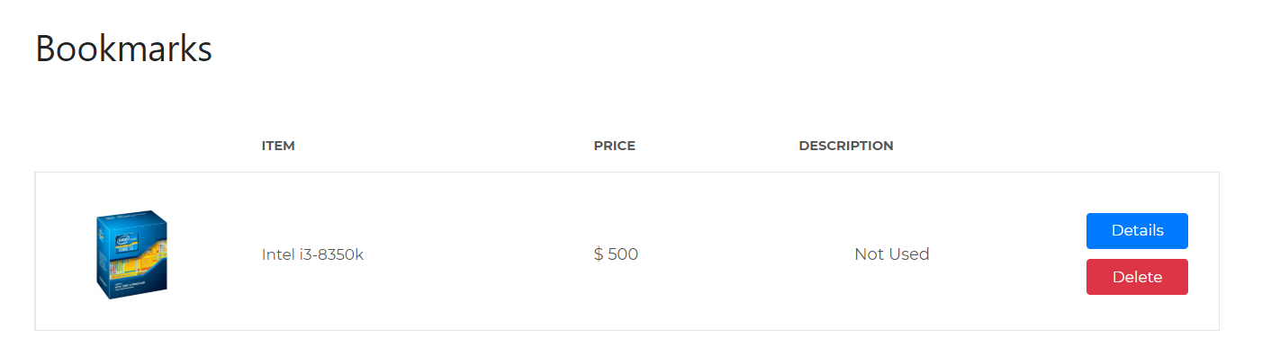

The item will be added to the bookmarks page. Here, it displays the basic information of the item, as well as a button linking to the additional information page. There is also a delete button to delete the bookmark.

**Search and sort of items: (Jun Wei)**

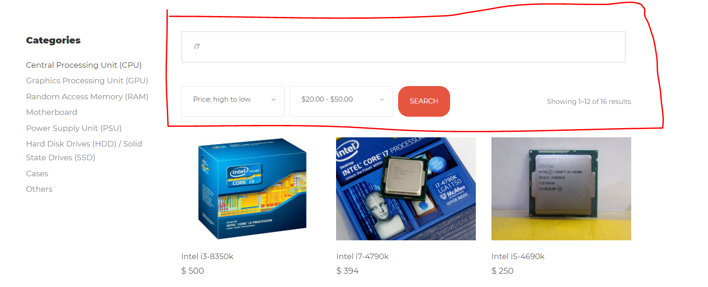

Users can search for specific keywords for an item category, the price range, and the type of sorting.

**Item listing: (Jun Wei)**

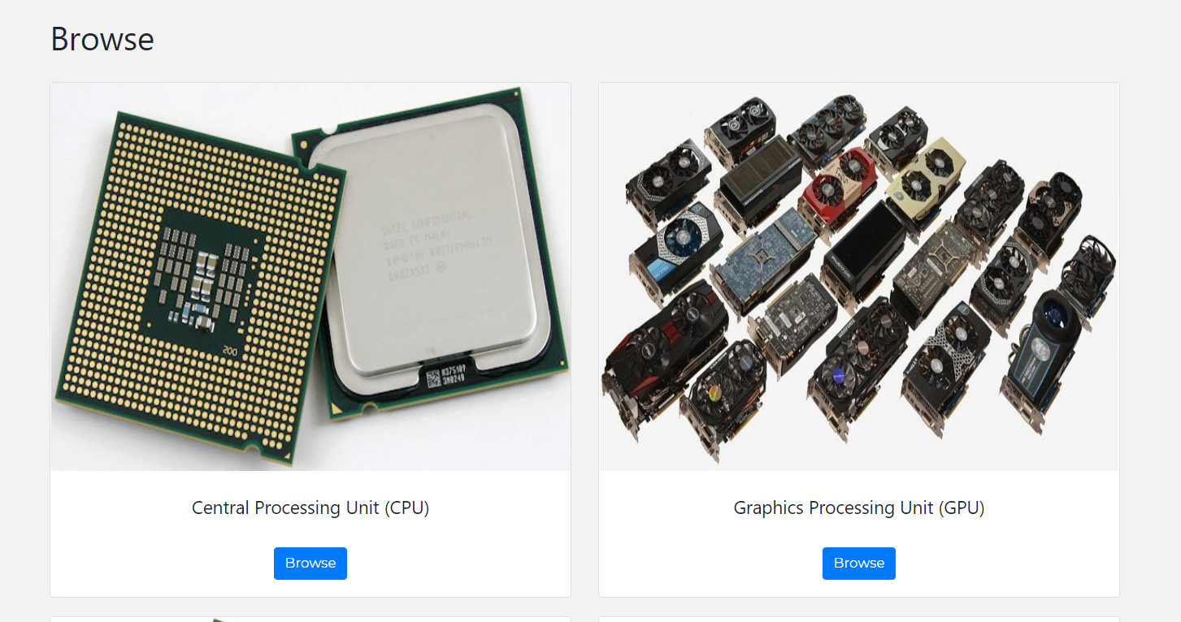

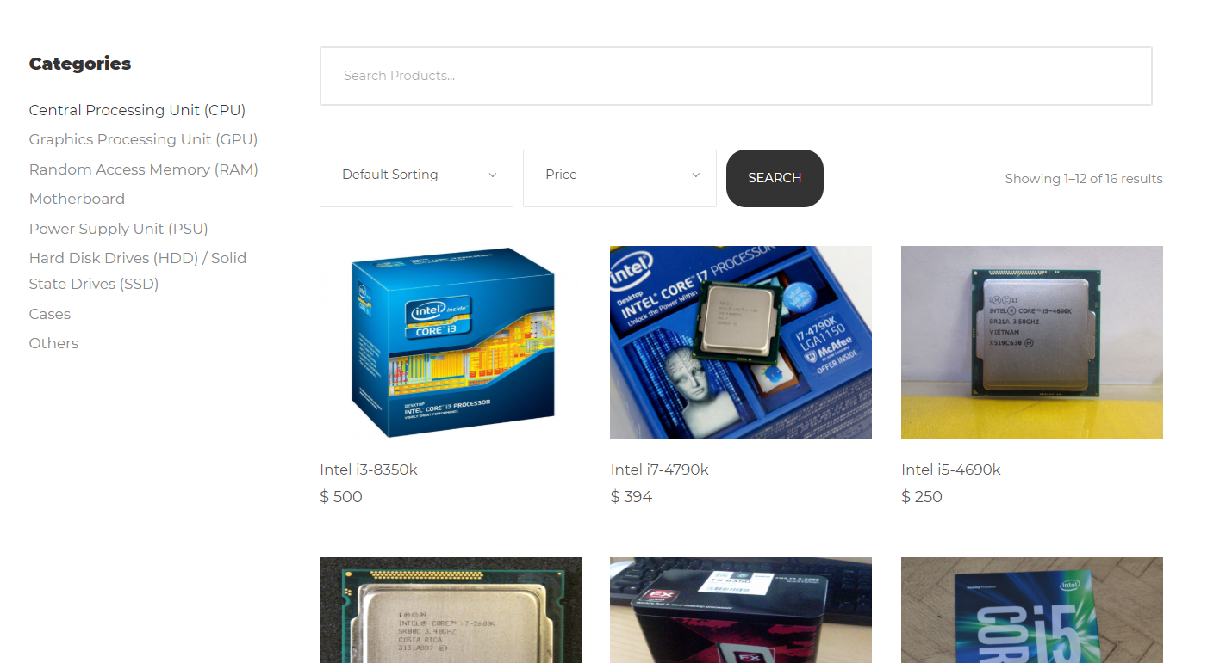



User can browse through listed items and selected item’s information.

**Add to cart & User Profile(integrating with Jia Jun & Zheng Ting): (Jun Wei)**

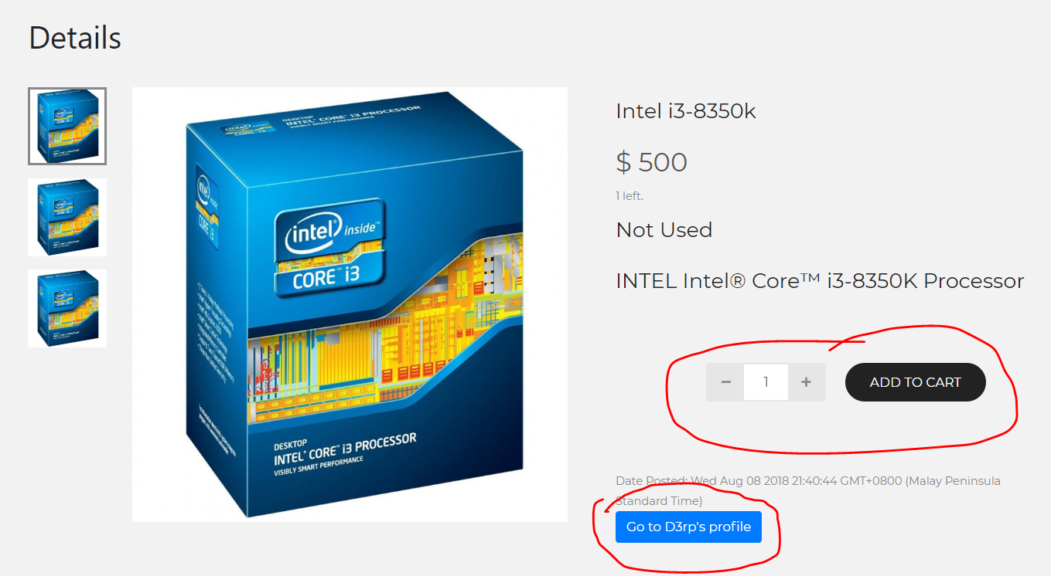

User can add to cart by selecting quantity lesser than quantity in stock and clicking on the “Add to cart” button.

User can also go to the seller’s profile by clicking on the blue button at the bottom.

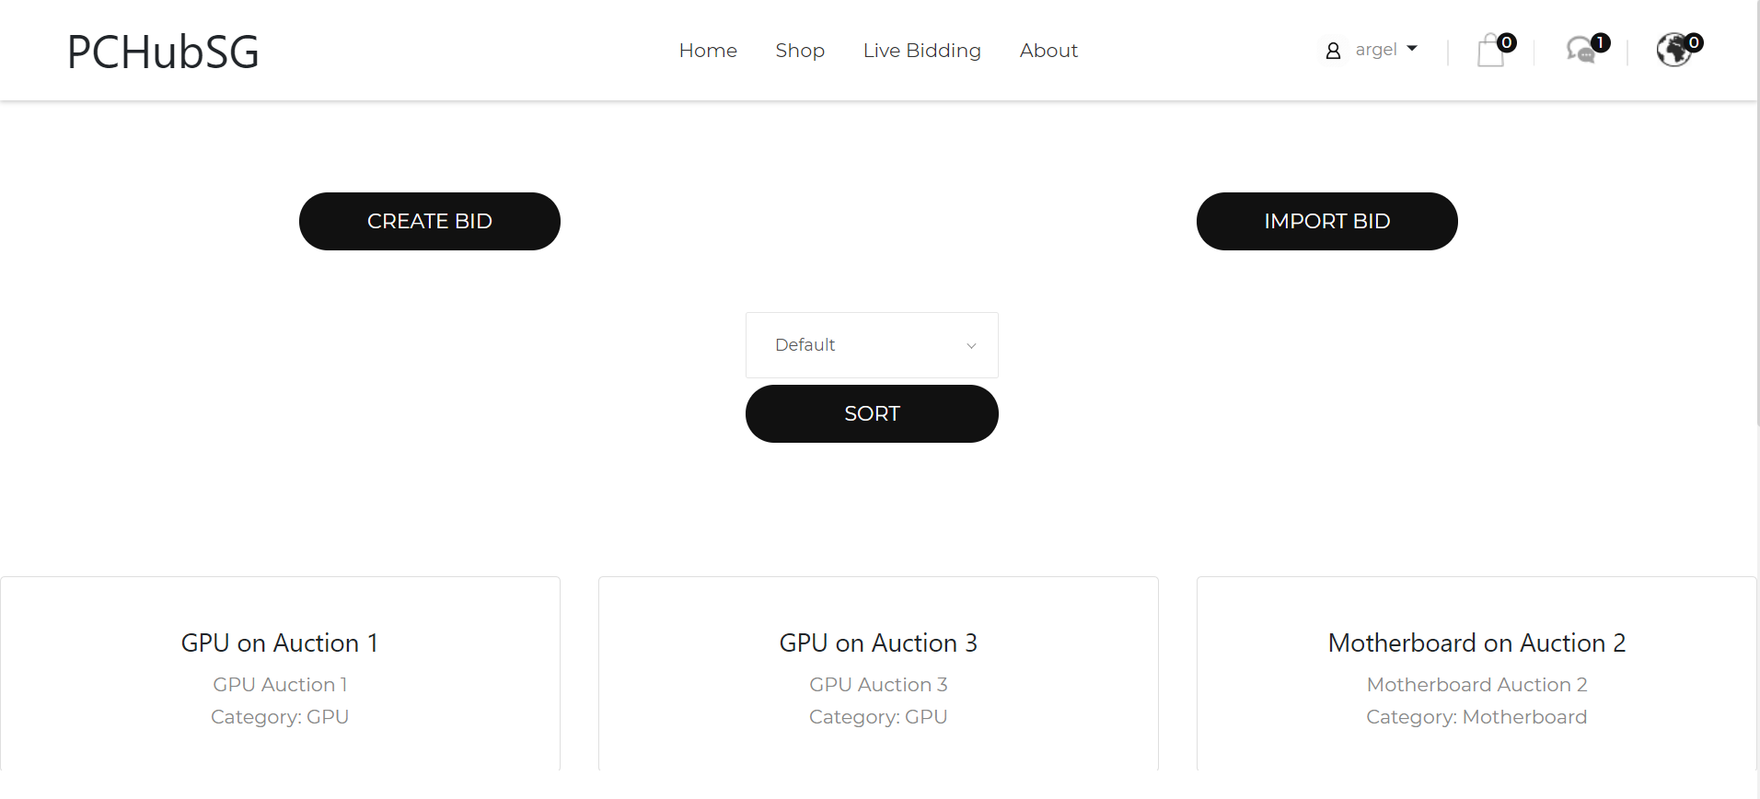**Bidding System (Argel)**

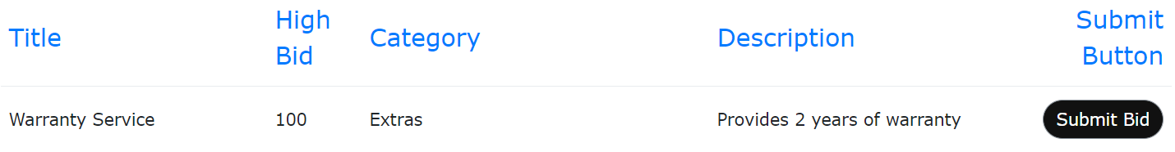The user is able to create his own bid through the ‘Create Bid’ button. The bid then gets displayed at the bidding page, which enables other users to see it. Also, the admin has special access by being able to access the ‘Import Bid’ button by clicking on it. It will look something like this:

The admin may then import a bid from the product listing page, and submit all the details of the product to be displayed in the bidding page.

The admin may also access pages like Edit/Delete bid page. It will all be shown correspondingly below: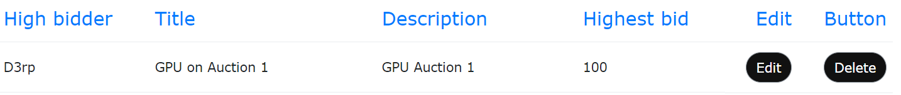

These 2 pages enables the admin to edit or delete a particular bid made by users. They can then ‘refer’ a user, which will grant the user a bonus of ‘20%’ on top of his bid.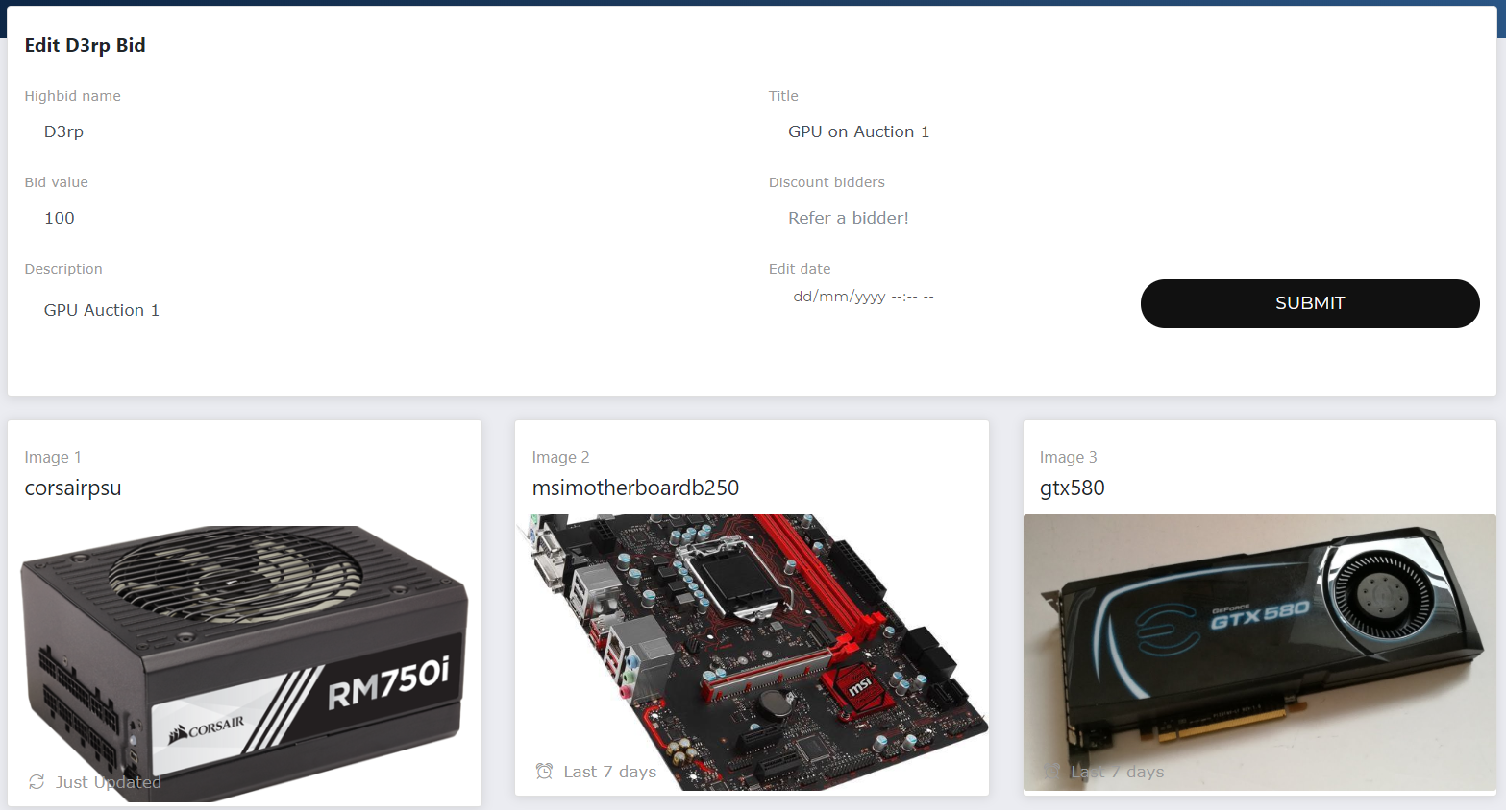

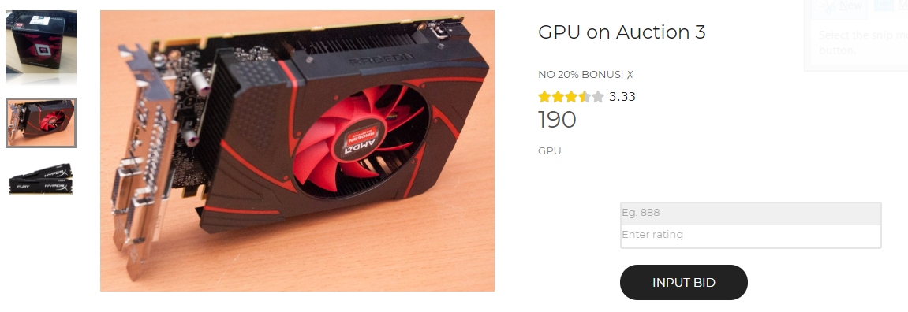Users would be able to outbid each other. The page would look something like this:

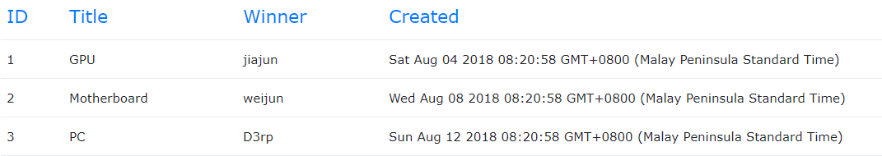Lastly, the admin is able to view the past bids transaction, and graphs with shows statistics of the past few bids. These pictures will be shown correspondingly below:

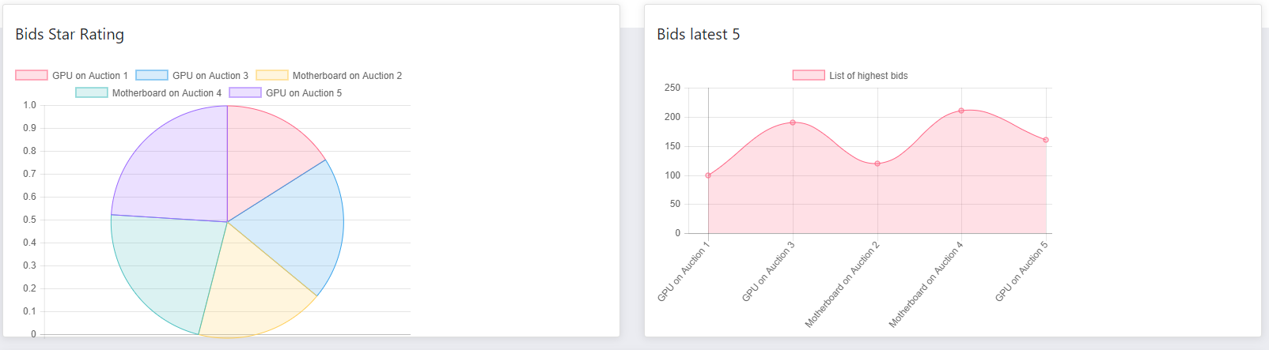

**Deletion of user accounts (Argel)**

The admin may be able to delete User accounts in the accounts list.

**Reflection on Learning Experience**

**Chow Jia Jun:**

I have learned to become a better group leader and a better listener to my group mates suggestion and opinions, i had also learned to be more tolerant and understanding towards my groupmates. Through this project, i have gained a deeper understanding to why communicating with your groupmates is extremely important for the project to succeed.

**Argel**:

OOADP has taught me more than just coding and technical skills. It has taught me how time is limited and working with others in a proper manner is crucial. Also, NodeJS is a new tool for me, and at first I found it very challenging, but soon realising that it was very similar to what we have learned last semester. As a member of the group, I have learned to utilise all the knowledge I have learned from other modules, such as Communication Skills, DBMS and C++ and contribute it to the group project. Throughout this project, I have also deeply learned and developed some of my morale values such as determination, integrity and responsibility. All in all, OOADP module has been a very good experience to me.

**Lim Zheng Ting:**

I have learnt to use a new project javascript framework, NodeJS and enhance my SQL learning, and with that, some other learning experiences involve taking advantages of my group members’ individual strengths and weaknesses, being more tolerant to group members when we are in disagreements, and with hard work and effort taken to self-study, it will eventually pay off.

**Liew Jun Wei:** Firstly, I have learnt NodeJS and learnt how the basic routing in projects works. Secondly, I also have a basic understanding of JQuery/Javascript by utilizing it in my functions. I have also learned how to use MySQL database and basic querying. After a multitude of errors, I realised that trial and error is an important part of the learning process, especially in coding. Another important part of coding is perseverance as without it, my function would have never worked. Time management is also an important part of project work. As I did not use my time wisely, I hope I have learned the consequences of last minute working. Last but most importantly, I have learned how to work and collaborate with my group members. By assigning work that is within the talents of the person, it is both beneficial to both the group and the team member. This can be done so by taking note of each person’s strengths and weaknesses.

**Tuak Zhong Wei :**

The thing I found out was that team management is the most important and the leader may either work hard with the rest or manipulate the talents of the other members.

Also important is that the system of school group project encourages corruption and cronyism because the system is virtually absolutely protected resulting in the freedom to the leader to threaten the other members with the loss of scores. As such the members will have to be either very talented, very hardworking or just very eager to give the leader gifts or favours.

I will seek to apply this knowledge even more eagerly.